You will research an Order in Class Aves from Connecticut and will organize your research into a visual project and oral presentation. The following information should be included in your presentation.

1. Anatomical Info
   1. Feather description
   2. Size of bird
   3. Sexual dimorphism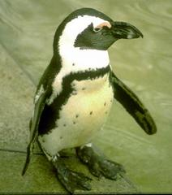
2. Breeding / reproduction
   1. Classification (genus & species)
   2. Clutch size
3. Eating behavior /diet
4. Geographic distribution and habitat
5. Migration / flight navigation / flight patterns
6. Pictures of males & female
7. Social behavior
   1. Nesting (type of nest)
   2. Parental care
   3. Territorial behavior
   4. Courting behavior
8. Vocalizations / bird call (Find a sonogram)

[Spheniscus demersus](http://animaldiversity.ummz.umich.edu/site/accounts/information/Spheniscus_demersus.html)

Ideas: Poster, PowerPoint, Collage, Sketches, Scrapbook, create a website, etc…

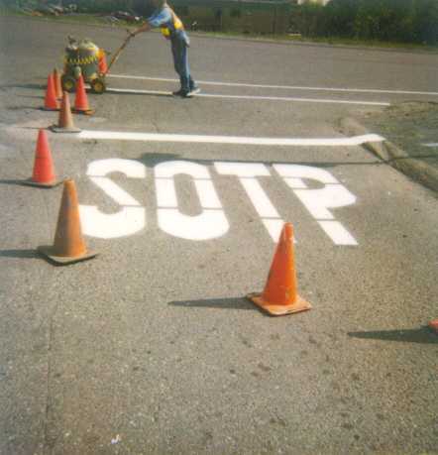

Hints:

* **DO NOT PLAGERIZE!**
* Make sure to proof-read and check the spelling on your presentation
* Use vocabulary common to high school juniors and seniors or teach them about it!
* Don’t waste too much time on special effects

The following birds from your selected Order should be included in your presentation.

|  |  |  |
| --- | --- | --- |
| Canada Goose Wood Duck Mallard Bufflehead Common Merganser Ring-necked Pheasant  Ruffed Grouse Wild Turkey Common Loon  Double-crested Cormorant Great Blue Heron Snowy Egret Turkey Vulture  Osprey Bald Eagle Sharp-shinned Hawk Cooper’s Hawk Northern Goshawk Red-tailed Hawk Golden Eagle  American Kestrel Peregrine Falcon Purple Finch  Baltimore Oriole | Herring Gull  Great Black-backed Gull Rock Pigeon  Mourning Dove Monk Parakeet  Barn Owl Eastern Screech-Owl Great Horned Owl Snowy Owl Common Nighthawk Whip-poor-will Chimney Swift Ruby-throated Hummingbird Red-headed Woodpecker Yellow-bellied Sapsucker Downy Woodpecker Northern Flicker Pileated Woodpecker Blue Jay American Crow Common Raven  House Finch American Goldfinch Evening Grosbeak | Purple Martin Tree Swallow Barn Swallow  Black-capped Chickadee Tufted Titmouse White-breasted Nuthatch House Wren Eastern Bluebird Wood Thrush American Robin Gray Catbird Northern Mockingbird European Starling  Cedar Waxwing Yellow Warbler Scarlet Tanager Eastern Towhee House Sparrow Song Sparrow Rose-breasted Grosbeak Indigo Bunting Red-winged Blackbird Eastern Meadowlark Brown-headed Cowbird |

Class: Aves

Order:

1. Anseriformes
2. Apodiformes
3. Charadriiformes
4. Ciconiiformes
5. Columbiformes
6. Falconiformes
7. Galliformes
8. Gaviiformes
9. Passeriformes
10. Piciformes
11. Psittaciformes
12. Sphenisciformes
13. Strigiformes
14. Struthioniformes